Separating Mixtures

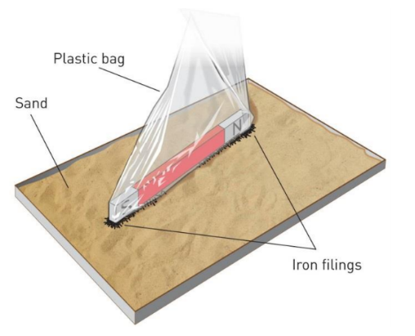

**STATION A: Separation using magnetism**

Equipment:

* Mixture of iron filing and sand
* Magnet
* Plastic bag

Method:

1. Place the magnet inside the plastic bag.
2. Pass the bagged magnet over the mixture so that the iron filings are attracted to it.
3. Turn the plastic bag carefully inside out so that all the iron filings are trapped inside.

Questions:

1. How well did this method separate the iron filings from the sand? Explain your answer.

|  |
| --- |
|  |

Magnetic materials are always made of metal, but ***not all metals are magnetic!***

Iron, nickel and cobalt are magnetic, so any material with these metals in it will be attracted to a magnet. For example, steel contains iron so a steel paperclip will be attracted to a magnet.

Other metals, such as aluminium, copper and gold, are NOT magnetic.

1. Could you use this method for all metals? Explain your answer.

|  |
| --- |
|  |

1. Could you use this method to separate a mixture of iron nails and nickel filings? Explain your answer.

|  |
| --- |
|  |

**STATION B: Separation by density #1**

Equipment:

* Mixture of sand and sawdust
* Water
* Spatula
* Stirring rod
* Two beakers

Method:

1. Place 3 heaped spatulas of the sand and sawdust mixture into a beaker.
2. Add enough water to cover the mixture and stir with the stirring rod.
3. Wait until sedimentation has occurred.
4. Use the spatula to scoop off any floating material from the top of the water, then place it into the second beaker.
5. Decant the water to retrieve the sand.
6. Draw a labelled diagram of your results.

Results:

Draw diagrams to show what the mixture looked like after sedimentation, after flotation and after decanting. ***Remember to use a pencil and ruler, and include neat labels!***

|  |
| --- |
| After sedimentation After flotation After decanting |

Questions:

1. What properties of the substances in the mixture make this method suitable for separating them? (*Hint: what did each substance do when the water was added?*)

|  |
| --- |
|  |

1. How successful was this method for separating and collecting the sand from the mixture? Explain your answer.

|  |
| --- |
|  |

1. Could you use this method to separate a mixture of sand and pebbles? Explain your answer.

|  |
| --- |
|  |

**STATION C: Separation by density #2**

Equipment:

* Mixture of sand and salt
* Water
* Spatula
* Stirring rod
* Two beakers

Method:

1. Place 3 heaped spatulas of the sand and salt mixture into a beaker.
2. Add enough water to cover the mixture and stir with the stirring rod.
3. Wait until sedimentation has occurred.
4. Use the spatula to scoop off any floating material from the top of the water, then place it into the second beaker.
5. Decant the water to retrieve the sand.
6. Draw a labelled diagram of your results.

Results:

Draw diagrams to show what the mixture looked like after sedimentation and after decanting. ***Remember to use a pencil and ruler, and include neat labels!***

|  |
| --- |
| After sedimentation After decanting |

Questions:

1. How successful was this method for collecting the sand from the mixture? Explain your answer.

|  |
| --- |
|  |

1. What are some difficulties with decanting?

|  |
| --- |
|  |

1. After separating the two substances from the mixture, what would need to be done to collect the salt as a solid?

|  |
| --- |
|  |